Mountain Academy of Martial Arts
Spring Tournament, demonstration and potluck 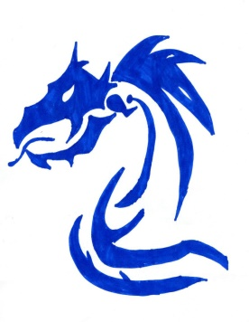
Date: April 8th, 2017
Time: 11:30 warm up, 12pm start
Where: CCMRD, 98 12th Ave, Idaho Springs, CO 80452
Cost: $40.00 day of event, $30.00 with pre-registration and pre-pay on-line or to your instructor. Kinder kicks fee: $20.00.

We will provide the activities and lots of prizes, best of show Adult and child will be given. Please bring a dish to share after the tournament.
Don’t forget in order to participate in Creative categories you must participate in the traditional category. These will be judged on creativity, difficulty and technique.
All participants will be grouped with others of about the same age and rank.
Forms: Traditional forms. You are not required to do your most recent form, you can choose a previously learned form.
Creative Forms: Everyone is welcome to participate.
Weapons: Traditional weapon forms. Green belt and above.
Creative weapons: Green belt and above.
Sparring: Point sparring.
Breaking: Wood, each participant can choose to break 3 to 5 boards, separately.
Kinder kicks: we will have an obstacle course, sumo wrestling and smaller boards for breaking for this group.
Please contact Mrs. Rich with any questions: (home) 303-582-5427; (cell) 303-517-4898; imyrrich@yahoo.com; facebook: Imy Rich.
Registration (Please turn in with your payment to your instructor)
Name:________________________________________________________________________
Age:__________________________________Rank:___________________________________Please circle what categories you will be participating in:
FORMS WEAPONS SPARRING BREAKING CR FORMS CR WEAPONS KINDER KICKS

